DATA RECEIVED FROM CARREFOUR ITALIA
Application Cool Roof on Assago Hypermarket
Energy Manager : Mr. Giovanni Piano
original surface application on roof
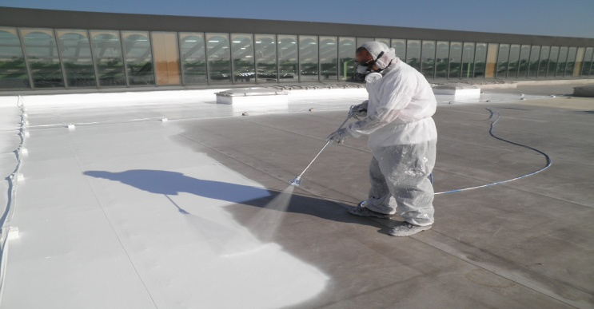
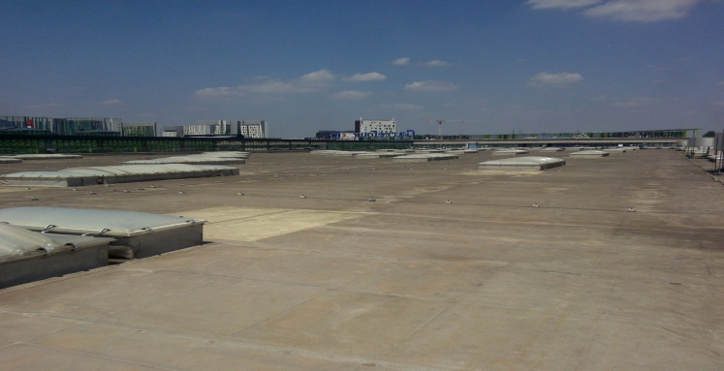

…. on roof top final result
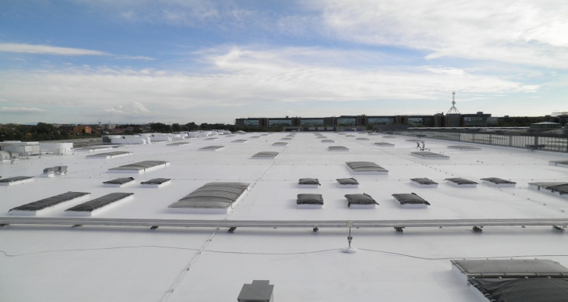
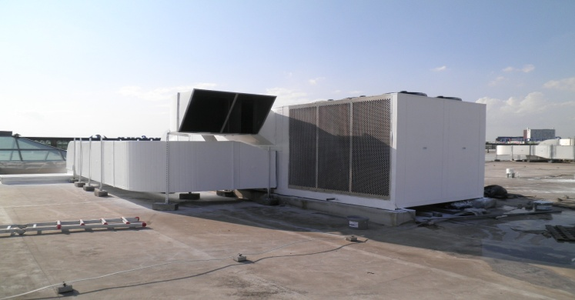

CONSUMPTION DATA
Sales area: 16.000 sqm. - sales area internal height: 7 mt.
Diesel consumption (average years 2004-2010): 150,000 liters / year
Natural gas consumption in 2011 (with new condensing boilers with natural gas): 95,000 mc
Total average annual electricity consumption: 7,000 MWh
Consumption (weekly) measured on multimeters CDZ (week average for the period July-August):

- WITHOUT COOL ROOF
2007: 44.573 kWh - 2008: 46.783 kWh - 2009: 46.627 kWh - 2010: 45.259 kWh
average : 45.810 kWh

- WITH COOL ROOF
2011: 33.500 kWh (-27%)
